**Visvesvaraya Technological University**

# Belagavi, Karnataka, 590 014.



## **AICTE Activity Point Programme on**

## **“Doubling The Village Income”**

(Non-Credit Activity of 2 Weeks (80-90 hours))

Submitted in partial fulfillment of the requirements for the award of

**Bachelor of Engineering**

**in**

**Computer Science and Engineering**

**Semester IV**

**Academic Year 2019-20**

***Department of Computer Science & Engineering***

K.L.E.SOCIETY’S

|  |  |  |
| --- | --- | --- |
| **C:\Users\shree\AppData\Local\Temp\ksohtml18708\wps2.jpg** | **K. L. E. INSTITUTE OF TECHNOLOGY,**  Opp. Airport, Gokul, Hubballi-580 030  Phone: 0836-2232681 Website: www.kleit.ac.in | **C:\Users\shree\AppData\Local\Temp\ksohtml18708\wps3.png** |

**Group Members :**

Aditi. A. Naik 2KE20CS002

Dhruvkumar. Bailkur 2KE20CS023

Akshata. G 2KE20CS026

Hitesh. Basangoudar 2KE20CS029

Rajnandini. K 2KE20CS031

Pooja. Gotakhindi 2KE20CS053

Komal. K. S 2KE20CS114

**Solid and Liquid**

**Waste Management in Rural Areas**

**Types**

* What is Waste?
* Solid Waste
* Liquid Waste
* SLWM under SBM Guidelines
* Institutional Arrangements for SLWM
* Criteria for Selection of Technology
* Waste management technologies
* Village Swachhtha Index

**Waste management**

Water, sanitation, and hygiene (WASH) directly impact human health and have far reaching consequences when ignored.

India is one of the fastest developing economies, but when it comes to WASH indicators, it continues to lag behind.

With a population of over 1.2 billion, there is amounting and urgent need to address sanitation. Solid and Liquid Waste Management SLWM) is one of the key components of Swachh Bharat Mission (SBM) (G), launched with the objective of bringing improvement in cleanliness, hygiene and the general quality of life in rural areas.

SLWM is the collection, transportation,processing, recycling, treatment, and disposal of waste material in a scientific manner.

The following guidelines presents a basic, quick introduction to Solid Liquid Waste Management (SLWM) in rural areas.

It is geared, particularly for district administrators to help focus on SLWM along with Open Defecation Free (ODF) activities.

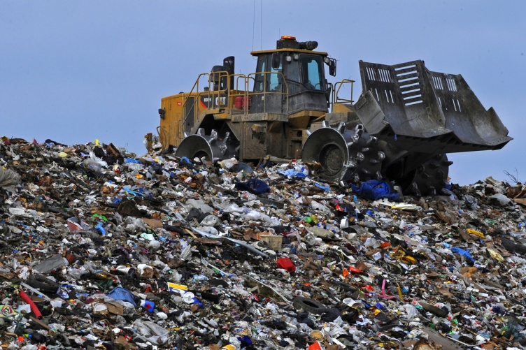**What Is Waste?**

Waste is any item beyond use in its current form and discarded as unwanted.

It can be solid or liquid with respective management methods.

Two types of wastes that are :

* Solid Waste
* Liquid Waste

**Solid Waste**

In rural areas, examples of solid waste include wastes from kitchens, gardens, cattle sheds, agriculture, and materials such as metal, paper, plastic, cloth, and so on. They are organic and inorganic materials with no remaining economic value to the owner produced by homes, commercial and industrial establishments. Most household waste in rural areas Is organic, with little inorganic material, and is non-toxic. Because of its environment -friendliness, composting is a highly suitable method of waste management in rural areas.

**Liquid Waste**

When water is used once and is no longer fit for human consumption or any other use, it

is considered to be liquid waste .Wastewater can be sub categorised as industrial and domestic.

Industrial wastewater is generated by manufacturing processes and is difficult to treat.

Domestic wastewater includes water discharged from homes, commercial complexes, hotels, and educational institutions.

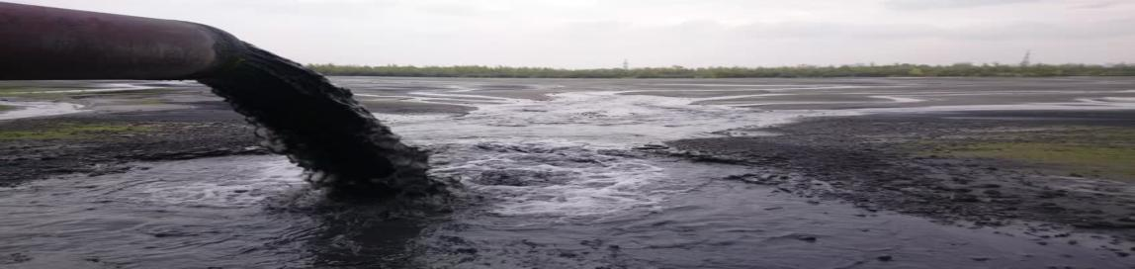

**SLWM under SBM Guidelines**

SBM focuses on generating awareness and providing community managed Sanitation systems. To implement SLWM initiatives economically and efficiently, ownership at grassroot level and

community involvement at all stages is critical.

Information, Education, and Communication (IEC) interventions should focus on SLWM to create a demand for a sustainable system.. This must lead to setting up systems for waste disposal in such a way that it has tangible impact on the population.

The community/Gram Panchayat (GP) has to be encouraged to come forward and

demand such a system, which they can subsequently operate and maintain.

Awareness and education campaigns should aim for panchayat officials, elected representatives, schools, non - governmental organisations (NGOs ) working in villages, shop keepers,

families, and general public.

The GP functionaries would be responsible for design, implementation, operation and

maintenance (O&M) of SLWM systems with support from respective state governments. Mechanisms for involving third parties in construction and management activities under GP

and community supervision can be explored. In such cases, absolute clarity in the roles and responsibilities of various stakeholders in managing SLWM systems Is a must. Community

contribution and appropriate user charges for sustainable SLWM initiatives are also desirable.

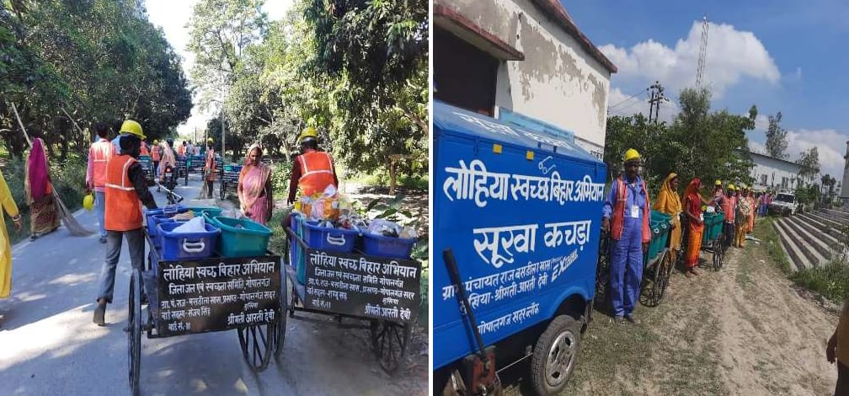

**Institutional Arrangements for SLWM**

All GPs are to be targeted for coverage with an SLWM project. SLWM projects for each GP should be part of Annual Implementation Plan (AIP) of a district.

The AIP should be approved by State Level Scheme Sanctioning Committee.

Each individual SLWM project may be approved at the District Water and Sanitation Committee (DWSC) level according to the technical and financial rules of the individual states.

Every state should have at least one SLWM consultant at the state level and one SLWM consultant in each District Water and Sanitation Mission (DWSM) / DWSC to guide preparations for SLWM projects.

**Criteria for Selection of Technology**

* Availability of soace near houses and housing pattern.
* Geophysical condition of the village including topography, soil structure and ground water conditions.
* Sources and pattern of water supply (individual / public).
* Availability of common space in and around the village.
* Economic status and human resources available with the GP.

**Waste management technologies**

**There are two types:**

**1) Solid waste management :**

* Composting Methods

**2)Liquid waste management :**

* Wastewater Treatment technologies

**Solid waste management :**

**Composting Methods**

**Technologies used are:**

* NADEP method
* Indore method
* Vermicomposting
* Bio gas from organic solid waste

**NADEP method**

Composting takes place in a rectangular brick tank with aeration holes. Organic material is

added in layers and compost is ready in almost 3 months.

**Advantages:**

* Composting can be done on a larger scale than using piles. All nutrients are retained in

the tank so resulting compost is more nutrient rich.

**Disadvantages:**

* Tanks work in 3 month rotations so at least 2 are needed which increases the cost. Large

quantities of soil and water are needed which can be difficult to transport in some areas.

* The entire tank should be filled within a maximum 48 hour period (24hrs is better).

**Conditions for use:**

* Tanks can be built in all conditions.
* The thatch roof protects the tank from moisture.
* Tank should be monitored to check for cracking of seal which would allow moisture to escape.

* Tanks require space and a lot of initial material so a community approach is better, using a communal space for the tank and agreeing the date for bringing material/ filling the tank.

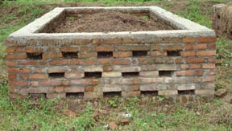

**Bangalore method**

Waste is composted anaerobically in a pit. Compost is ready in 6 - 8 months

**Advantages:**

* Can accept municipal waste and night soil.
* Good for dry areas and no O+tM is needed

**Disadvantages:**

* Cannot be used in wet areas as the pit may become waterlogged. Gases produced can

smell and the pit requires quite a large space.

* Composting process is slow

**Conditions for use:**

* Useful in areas where the use of piles islimited by severe weather conditions

e.g. strong winds and sun.

Can be done at the household level where space permits as no O+M is required. Very

cheap compared to tank methods as no infrastructure is required

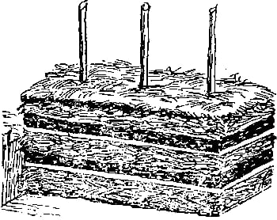

**Indore method**

Waste is cut into small pieces and spread 10 - 15cm thick above ground or ina pit.

Compost is ready in 4 months

**Advantages:**

* No infrastructure is needed and process Is relatively quick

**Disadvantages:**

* Nutrients are lost to the soil. Regular turning Is needed (every 5 days).
* Cannot be used in wet areas or areas with heavy rainfall due to waterlogging

**Conditions for use:**

* Pit/heap is unprotected so may need some protection from animals/children etc.
* A windbreaker can be used to reduce effects of drying out.
* Very cheap compared to tank methods as no infrastructure is required.

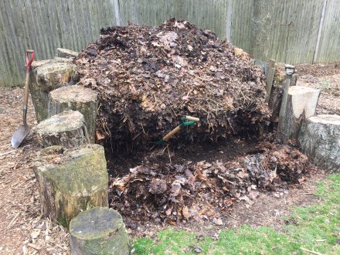**Vermicomposting**

Composting using a specific species of worms to break down waste Compost is ready in 3 - 4 months but compost must be removed in stages as the worms process it

**Advantages:**

* More efficient than normal composting and produces richer compost.

**Disadvantages:**

* Needs a vermitank or verminbed and worms need to be bought or grown which increases

cost .

* Needs more O+M than normal

**Conditions for use:**

* Wormsâ€™ optimal temperature range is 15 - 35 degrees Celsius.
* Lower temperatures hamper reproduction and higher temperatures kill the worms or make them leave.

* Worms are very sensitive to drought SO use in very dry areas Is not recommended unless a reliable water source is available.

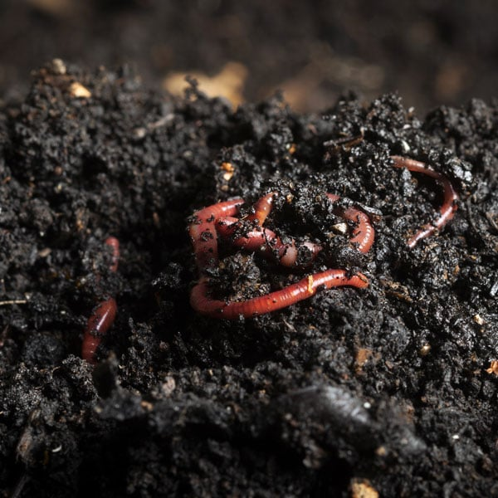

**Bio gas from organic solid waste**

Bio gas is created by the decomposition of organic waste in anaerobic conditions. The resulting gas can be let off into the atmosphere or it can be tapped for burning as a fuel. As well as the biogas, the process also produces a slurry which can be used as a nutrient rich fertilizer.

**Disadvantages:**

Gas accumulation rates are slower than rates of use but for areas reliant on wood as a fuel for cooking biogas provides an excellent alternative.

**Conditions for use:**

The biogas plant can be linked to the family or community toilet or it can be a standalone system to which wastes are added. There are many different designs available. The choice of design will be influenced primarily by the desired capacity, the space available to install the plant, the type of feed material (cattle dung has higher gas producing capacities than human waste) and the finances available for construction. Waste should be added daily to ensure continuous gas production. Stoves, cookers or lamps must be converted to accept biogas but the gas itself burns without odour.

**Liquid waste management:**

**Wastewater Treatment Technologies**

**Technologies used are:**

* Waste Stabilisation Pond System
* Duckweed Pond System
* Constructed Wetland
* Upflow Anaerobic Sludge Blanket
* Anaerobic Baffled Filter
* Package Aeration System
* Extended Aeration System
* Sequencing Batch Reactor System
* Soil Bio Technology
* Waste Stabilisation Pond System

**Duckweed Pond System**

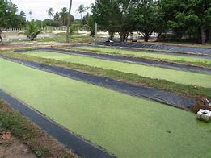 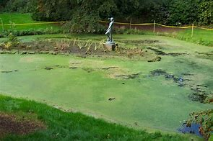

**Lemnoideae** is a subfamily of flowering [aquatic plants](https://en.wikipedia.org/wiki/Aquatic_plant), known as **duckweeds**, **water lentils**, or **water lenses**. They float on or just beneath the surface of still or slow-moving bodies of [fresh water](https://en.wikipedia.org/wiki/Fresh_water) and [wetlands](https://en.wikipedia.org/wiki/Wetlands). Also known as **bayroot**, they arose from within the arum or aroid family ([Araceae](https://en.wikipedia.org/wiki/Araceae" \o "Araceae)),[[1]](https://en.wikipedia.org/wiki/Lemnoideae#cite_note-tam-1) so often are classified as the subfamily Lemnoideae within the family [Araceae](https://en.wikipedia.org/wiki/Araceae" \o "Araceae). Other classifications, particularly those created prior to the end of the twentieth century, place them as a separate family, **Lemnaceae**.

These plants have a simple structure, lacking an obvious [stem](https://en.wikipedia.org/wiki/Stem_(botany)) or [leaves](https://en.wikipedia.org/wiki/Leaf). The greater part of each plant is a small organized "[thallus](https://en.wikipedia.org/wiki/Thallus)" or "[frond](https://en.wikipedia.org/wiki/Frond)" structure only a few cells thick, often with air pockets ([aerenchyma](https://en.wikipedia.org/wiki/Aerenchyma)) that allow it to float on or just under the water surface. Depending on the species, each plant may have no root or may have one or more simple rootlets.[[2]](https://en.wikipedia.org/wiki/Lemnoideae#cite_note-2)

Reproduction is mostly by [asexual](https://en.wikipedia.org/wiki/Asexual_reproduction) [budding](https://en.wikipedia.org/wiki/Budding) ([vegetative reproduction](https://en.wikipedia.org/wiki/Vegetative_reproduction)), which occurs from a [meristem](https://en.wikipedia.org/wiki/Meristem) enclosed at the base of the frond. Occasionally, three tiny "flowers" consisting of two [stamens](https://en.wikipedia.org/wiki/Stamens) and a [pistil](https://en.wikipedia.org/wiki/Pistil) are produced, by which [sexual reproduction](https://en.wikipedia.org/wiki/Sexual_reproduction) occurs. Some view this "flower" as a [pseudanthium](https://en.wikipedia.org/wiki/Pseudanthium" \o "Pseudanthium), or reduced [inflorescence](https://en.wikipedia.org/wiki/Inflorescence), with three flowers that are distinctly either female or male and which are derived from the [spadix](https://en.wikipedia.org/wiki/Spadix_(botany)) in the Araceae. Evolution of the duckweed inflorescence remains ambiguous due to the considerable evolutionary reduction of these plants from their earlier relatives.

**Constructed Wetland**

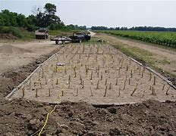

A **constructed wetland** (**CW**) is an artificial [wetland](https://en.wikipedia.org/wiki/Wetland) to treat [sewage](https://en.wikipedia.org/wiki/Sewage), [greywater](https://en.wikipedia.org/wiki/Greywater), [stormwater](https://en.wikipedia.org/wiki/Stormwater) runoff or [industrial wastewater](https://en.wikipedia.org/wiki/Industrial_wastewater_treatment). It may also be designed for land reclamation after [mining](https://en.wikipedia.org/wiki/Mining), or as a [mitigation](https://en.wikipedia.org/wiki/Flood_mitigation) step for natural areas lost to [land development](https://en.wikipedia.org/wiki/Land_development). Constructed wetlands are engineered systems that use the natural functions of [vegetation](https://en.wikipedia.org/wiki/Vegetation), [soil](https://en.wikipedia.org/wiki/Soil), and organisms to provide [secondary treatment](https://en.wikipedia.org/wiki/Secondary_treatment) to [wastewater](https://en.wikipedia.org/wiki/Wastewater). The design of the constructed wetland has to be adjusted according to the type of wastewater to be treated. Constructed wetlands have been used in both centralized and [decentralized wastewater systems](https://en.wikipedia.org/wiki/Decentralized_wastewater_system). Primary treatment is recommended when there is a large amount of suspended solids or soluble organic matter (measured as [BOD](https://en.wikipedia.org/wiki/Biochemical_oxygen_demand) and [COD](https://en.wikipedia.org/wiki/Chemical_oxygen_demand)).

Similar to natural wetlands, constructed wetlands also act as a [biofilter](https://en.wikipedia.org/wiki/Biofilter) and/or can remove a range of [pollutants](https://en.wikipedia.org/wiki/Pollutant) (such as organic matter, [nutrients](https://en.wikipedia.org/wiki/Nutrient_pollution), [pathogens](https://en.wikipedia.org/wiki/Pathogen), [heavy metals](https://en.wikipedia.org/wiki/Heavy_metal_(chemistry))) from the water. Constructed wetlands are designed to remove water pollutants such as suspended solids, organic matter and nutrients (nitrogen and phosphorus).

There are two main types of constructed wetlands: subsurface flow and surface flow constructed wetlands. The planted vegetation plays an important role in contaminant removal. The filter bed, consisting usually of [sand](https://en.wikipedia.org/wiki/Sand) and [gravel](https://en.wikipedia.org/wiki/Gravel), has an equally important role to play.[[2]](https://en.wikipedia.org/wiki/Constructed_wetland#cite_note-hoffmann-2) Some constructed wetlands may also serve as a [habitat](https://en.wikipedia.org/wiki/Habitat) for native and migratory [wildlife](https://en.wikipedia.org/wiki/Wildlife), although that is not their main purpose. Subsurface flow constructed wetlands are designed to have either horizontal flow or vertical flow of water through the gravel and sand bed. Vertical flow systems have a smaller space requirement than horizontal flow systems.

**Upflow Anaerobic Sludge Blanket**

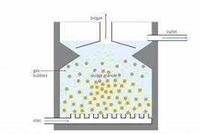

UASB uses an [anaerobic](https://en.wikipedia.org/wiki/Anaerobic_digestion) process whilst forming a blanket of granular sludge which suspends in the tank. Wastewater flows upwards through the blanket and is processed (degraded) by the [anaerobic microorganisms](https://en.wikipedia.org/wiki/Anaerobic_organism). The upward flow combined with the settling action of [gravity](https://en.wikipedia.org/wiki/Gravity) suspends the blanket with the aid of [flocculants](https://en.wikipedia.org/wiki/Flocculant). The blanket begins to reach maturity at around three months. Small sludge granules begin to form whose surface area is covered in aggregations of bacteria. In the absence of any support matrix, the flow conditions create a selective environment in which only those microorganisms capable of attaching to each other survive and proliferate. Eventually the aggregates form into dense compact biofilms referred to as "granules".[[2]](https://en.wikipedia.org/wiki/Upflow_anaerobic_sludge_blanket_digestion#cite_note-2)

[Biogas](https://en.wikipedia.org/wiki/Biogas) with a high concentration of [methane](https://en.wikipedia.org/wiki/Methane) is produced as a by-product, and this may be captured and used as an energy source, to generate [electricity](https://en.wikipedia.org/wiki/Electricity) for export and to cover its own running power. The technology needs constant monitoring when put into use to ensure that the sludge blanket is maintained, and not washed out (thereby losing the effect). The heat produced as a by-product of electricity generation can be reused to heat the digestion tanks.

The blanketing of the sludge enables a dual solid and hydraulic (liquid) retention time in the digesters. Solids requiring a high degree of digestion can remain in the reactors for periods up to 90 days.[[3]](https://en.wikipedia.org/wiki/Upflow_anaerobic_sludge_blanket_digestion#cite_note-3) Sugars dissolved in the liquid waste stream can be converted into gas quickly in the liquid phase which can exit the system in less than a day.

UASB reactors are typically suited to dilute waste water streams (3% TSS with particle size >0.75mm).

**Anaerobic Baffled Filter**

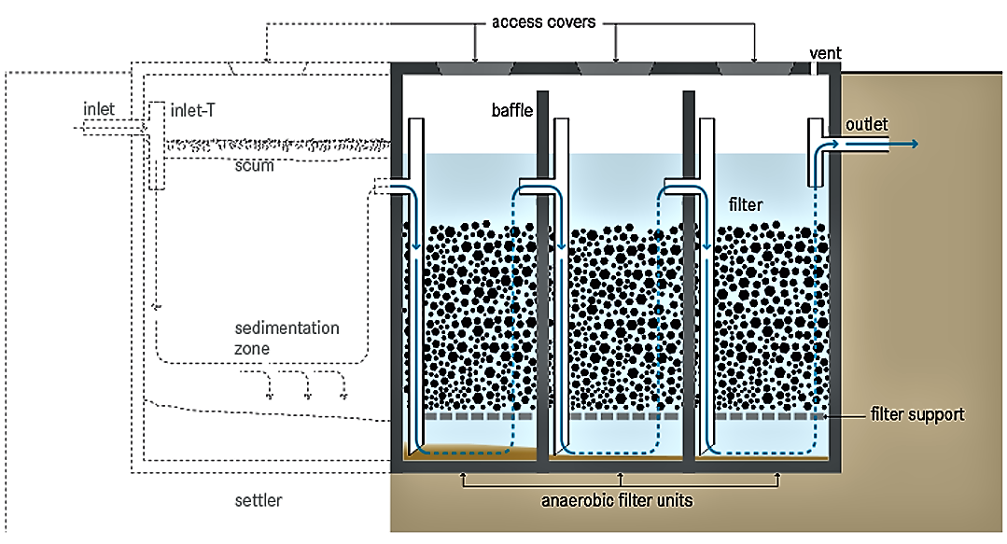

[**Anaerobic**](https://sswm.info/content/anaerobic) filters are used as secondary treatment step in household greywater or blackwater treatment systems. They are also used, together with other treatment units in a so-called decentralised wastewater treatment system (DEWATS) (e.g. for biodegradable industrial wastewater).

An anaerobic filter is an attached biofilm system (fixed bed or fixed film reactor, see also [**fixed film activated sludge**](https://sswm.info/water-nutrient-cycle/wastewater-treatment/hardwares/semi-centralised-wastewater-treatments/fixed-film-activated-sludge)) that aims at removing non-settleable and dissolved solids (MOREL & DIENER 2006). As [**septic tanks**](https://sswm.info/factsheet/septic-tank) or [**anaerobic baffled reactors**](https://sswm.info/factsheet/anaerobic-baffled-reactor-(abr)), anaerobic filters are based on the combination of a physical treatment (settling) and a biological treatment (see also [**anaerobic digestion**](https://sswm.info/arctic-wash/module-4-technology/further-resources-wastewater-treatment/anaerobic-digestion-%28general%29)). It comprises a watertight tank containing several layers of submerged media, which provide surface area for bacteria to settle. As the wastewater flows through the filter usually from bottom to top (up-flow), it comes into contact with the biomass on the filter and is subjected to anaerobic degradation (MOREL & DIENER 2006).

The construction of anaerobic filters is similar to [**septic tanks**](https://sswm.info/factsheet/septic-tank) but generally there are several chambers and additional baffels in order to ensure upflow. Consequently, non-settleable and dissolved solids are also treated as they are brought into close contact with the active bacterial mass fixed on the filter material. The bacteria tend to fix themselves on reactor walls and filter material (e.g. gravel, rocks, cinder or specially frmed plastic pieces) and anaerobically digests the dispersed or dissolved organic matter within short retention times. The larger the surface for bacterial growth, the quicker the digestion. A good filter material provides 90 to 300 m2 surface area per m3 of occupied reactor volume (SASSE 1998; MOREL 2006). A rough surface provides a larger area, at least in the starting phase. Later on, the biofilm that grows on the filter mass quickly closes the smaller groves and holes (SASSE 1998). The digestion process itself is similar to the one taking place in [**ABRs**](https://sswm.info/factsheet/anaerobic-baffled-reactor-(abr)), but in ABRs the contact of the solids and the bacteria is provided by discharging wastewater to the bottom directly into the biomass, which is settled in the sludge.**Package Aeration System**

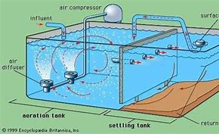

A **package manager** or **package-management system** is a collection of software tools that automates the process of installing, upgrading, configuring, and removing computer programs for a [computer](https://en.wikipedia.org/wiki/Computer) in a consistent manner.[[1]](https://en.wikipedia.org/wiki/Package_manager#cite_note-1)

Packages contain [metadata](https://en.wikipedia.org/wiki/Metadata), such as the software's name, description of its purpose, version number, vendor, [checksum](https://en.wikipedia.org/wiki/Checksum) (preferably a [cryptographic hash function](https://en.wikipedia.org/wiki/Cryptographic_hash_function)), and a list of [dependencies](https://en.wikipedia.org/wiki/Coupling_(computer_programming)) necessary for the software to run properly. Upon installation, metadata is stored in a local package database. Package managers typically maintain a database of software dependencies and version information to prevent software mismatches and missing prerequisites. They work closely with [software repositories](https://en.wikipedia.org/wiki/Software_repository), [binary repository managers](https://en.wikipedia.org/wiki/Binary_repository_manager), and [app stores](https://en.wikipedia.org/wiki/App_store).

Package managers are designed to eliminate the need for manual installs and updates. This can be particularly useful for large enterprises whose operating systems typically consist of hundreds or even tens of thousands of distinct software packages.[[2]](https://en.wikipedia.org/wiki/Package_manager#cite_note-2)

Extended aeration is typically used in prefabricated "package plants" intended to minimize design costs for waste disposal from small communities, tourist facilities, or schools. In comparison to traditional activated sludge, longer mixing time with aged sludge offers a stable biological ecosystem better adapted for effectively treating waste load fluctuations from variable occupancy situations. Supplemental feeding with something like sugar is sometimes used to sustain sludge microbial populations during periods of low occupancy; but population response to variable food characteristics is unpredictable, and supplemental feeding increases waste sludge volumes. Sludge may be periodically removed by septic tank pumping trucks as sludge volume approaches storage capacity.

**Sequencing Batch Reactor System**

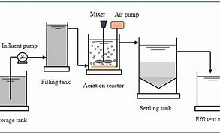

**Sequencing batch reactors** (**SBR**) or **sequential batch reactors** are a type of [activated sludge](https://en.wikipedia.org/wiki/Activated_sludge) process for the [treatment of wastewater](https://en.wikipedia.org/wiki/Wastewater_treatment). SBR reactors treat wastewater such as [sewage](https://en.wikipedia.org/wiki/Sewage) or output from [anaerobic digesters](https://en.wikipedia.org/wiki/Anaerobic_digester) or [mechanical biological treatment](https://en.wikipedia.org/wiki/Mechanical_biological_treatment) facilities in batches. Oxygen is bubbled through the mixture of wastewater and activated sludge to reduce the organic matter (measured as [biochemical oxygen demand](https://en.wikipedia.org/wiki/Biochemical_oxygen_demand) (BOD) and [chemical oxygen demand](https://en.wikipedia.org/wiki/Chemical_oxygen_demand) (COD)). The treated effluent may be suitable for discharge to surface waters or possibly for use on land.

Aeration times vary according to the plant size and the composition/quantity of the incoming liquor, but are typically 60 to 90 minutes. The addition of [oxygen](https://en.wikipedia.org/wiki/Oxygen) to the liquor encourages the multiplication of [aerobic bacteria](https://en.wikipedia.org/wiki/Aerobic_bacteria) and they consume the nutrients. This process encourages the conversion of nitrogen from its [reduced](https://en.wikipedia.org/wiki/Redox) [ammonia](https://en.wikipedia.org/wiki/Ammonia) form to [oxidized](https://en.wikipedia.org/wiki/Oxidized) [nitrite](https://en.wikipedia.org/wiki/Nitrite) and [nitrate](https://en.wikipedia.org/wiki/Nitrate) forms, a process known as [nitrification](https://en.wikipedia.org/wiki/Nitrification).

[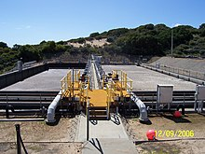](https://en.wikipedia.org/wiki/File:Bunbury_WWTP_SBR_002.jpg)

To remove [phosphorus](https://en.wikipedia.org/wiki/Phosphorus) compounds from the liquor, [aluminium sulfate](https://en.wikipedia.org/wiki/Aluminium_sulfate" \o "Aluminium sulfate) (alum) is often added during this period. It reacts to form non-soluble compounds, which settle into the sludge in the next stage.

**Soil Bio Technology**

|  |
| --- |
|  |
| **Overview**  Soil Bio- technology is a terrestrial system for wastewater treatment which is based on the principle of trickling filter.  In this system, combination of physical processes like  sedimentation, infiltration and biochemical processes are carried out to remove the suspended solids, organic and inorganic contents of the wastewater. |
| Suitable mineral constitution, culture containing native micro-flora and bio- indicator plants are the key components of the system.  It is also known as Constructed Soil Filter (CSF). SBT systems are constructed from RCC, stone-masonry or soil bunds.  It consists of raw water tank, bioreactor containment, treated water tank, piping and pumps. |
| **Salient features**   * The process can be run on batch or continuous mode. * No sludge production * Mechanical aeration is not required. * The overall time of operation is 6-7 hours per day. * The soil biotechnology system bed is dried prior to next cycle of use. |

**Village Swachhtha Index**

Government of India has developed a detailed statistical analysis to identify factors that may be

necessary for measuring cleanliness across India in order to raise awareness about cleanliness

and to instila sense of competitiveness amongst villages, GPs, Blocks, Districts and States.

Based on several consultations with states and experts and a large survey involving over

70,000 households in 75 districts across the country, Cleanliness Index and SLWM index have

been defined.

Cleanliness index captures the overall cleanliness of a village including village households

which have access to and are using safe toilets and environmental friendliness.

SLWM index captures environmenta lfriendliness as evidenced by absence of litter

around houses and public places and no stag nant water around house holds.

SLWM index captures environmental friendliness as evidenced by absence of litter around

houses and public places and no stagnant water around house holds.

SLWM index is derived out of Cleanliness index as per the following:

* Village Cleanliness Index (C) is defined as

C = 0.4*X1 + 0.3*X2 + 0.1*X3 + 0.2*X4

* In addition, Village SLWM Index is defined

as S = 0.5*X2 + 0.17*X3 + 0.33*X4 where,

* X1 = % of households having access to

safe sanitation

* X2 = % of households having no litter

around them

* X3 = % of households having no stagnant

waste water around them

* X4 = % level of litter free around public

places

* Gram Sabhas are responsible to estimate the various factors defined above that comprises the cleanliness index.